CSC131 SP'19 In-Class Activity

Please evaluate the following designs and indicate possible improvement (if needed). ____________________________________________________________________________________

Design 1 (Strategy)

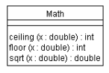 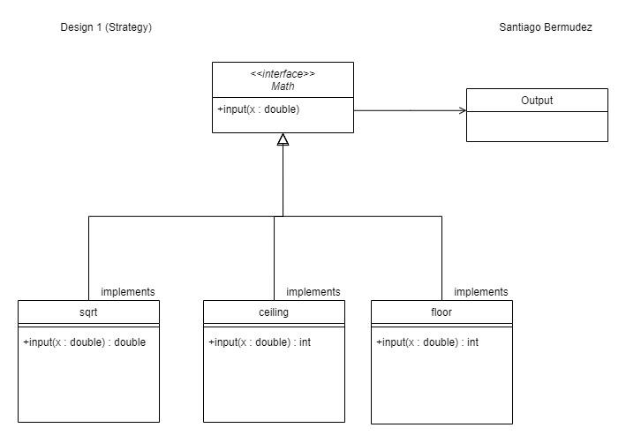

Design 2 (Template)

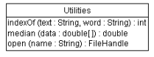

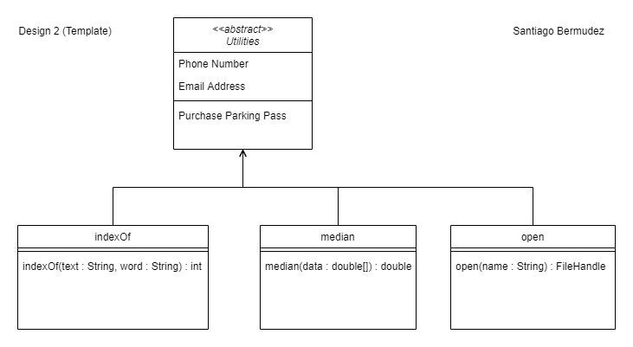

Design 3 (State) *This one seems fine!

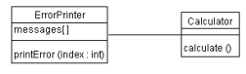

Design 4 (Singleton)

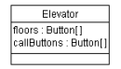

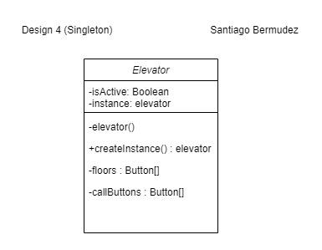

Design 5 (Observer)

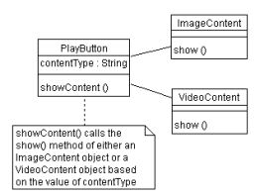

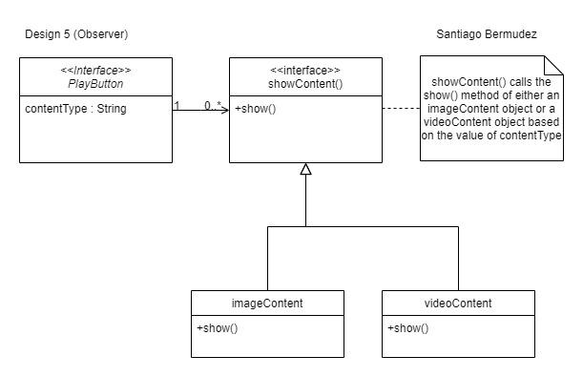

Design 6 (Composite)

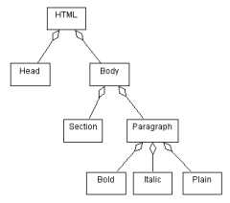

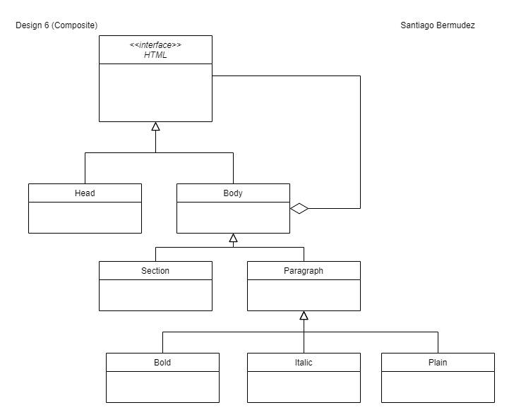

Design 7 (Iterator)

